Mini-HART

[The Modified SPOT-Micro]

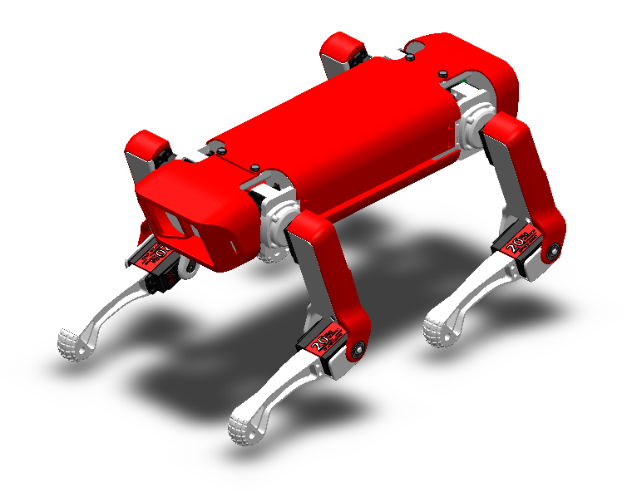Detailed Instruction Manual

Table of Contents:

|  |  |
| --- | --- |
| Bill of Materials | 3 |
| 3D Printing Guide | 4 |
| Parts List | 6 |
| Mechanical Assembly | 11 |
| -Body Assembly | 11 |
| -Legs Assembly | 15 |
| -Shoulders Assembly | 19 |
| -Covers Assembly | 24 |
| -Final Assembly | 25 |
| Electrical Assembly | 29 |
| -Pin Diagrams | 29 |
| -Motor Calibration | 30 |
| -Motor Connections | 31 |
| -Wire Connections | 33 |
| -Battery Connections | 35 |

Bill of Materials:



Additionally, the full bill of materials with amazon links and cost estimates can be found on the Mini-HART git-hub ( ). Some quantities of the items in the amazon packages might be more than what is needed, and some of the items like the servo motors which are more easily damaged have extra items ordered than the required amount so there are some back-up parts.

3D Printing Guide:

Using the STL files provided by the Spot Micro community and/or modified parts that improve on the design and a 3D printer, print out the specified number of parts using a 3D printer. There are different types of materials that can be printed, including PLA, ABS, or PETG, and is up to the user to decide which material based on each one’s pros and cons. When printing, support material is a must, infill can be set to 13% as higher percentages provide little difference and cost more material, and the layer thickness can range between 0.2 to 0.35, where the smaller the values result in a smoother finish. Tools to remove support will be needed.

*Mini-HART Essential 3D Printed Parts*: ( )

|  |  |
| --- | --- |
| **QUANTITY** | **PART NAME** |
| **1** | Modified Base Plate (1 Arduino + 1 RPi ¾ + 1 PCA9685) |
| **1** | Modified Left Side Plate (1 Arduino + 1 RPi ¾ + 1 PCA9685) |
| **1** | Modified Right Side Plate (1 Arduino + 1 RPi ¾ + 1 PCA9685) |
| **2** | Inside Shoulder |
| **2** | Outside Shoulder |
| **4** | Foot |
| **2** | Left Shoulder |
| **2** | Left Arm |
| **2** | Left Leg |
| **2** | Right Shoulder |
| **2** | Right Arm |
| **2** | Right Leg |
| **1** | Left Ultrasonic Plate |
| **1** | Right Ultrasonic Plate |
| **1** | Front Cover |
| **1** | Rear Cover |
| **1** | Top Cover |
| **1** | Bottom Cover |
| **2** | Left Arm Cover |
| **2** | Right Arm Cover |

Some additional parts can be printed that were innovated off the original design or created for additional purposes can be printed as well and provide some useful modifications to the robot and the builders desires. These modifications listed are compatible with the original design, however some repositories are not so be sure to read the README.md files to make sure. Some additional parts, such as screws and bearing might be needed as well for these additional parts.

*Additional 3D Printed Parts:* ( )

|  |  |
| --- | --- |
| QUANTITY | PART NAME |
| 1 | Base Plate (1 Arduino) [Original Design] |
| 1 | Left Side Plate (1 Arduino) [Original Design] |
| 1 | Right Side Plate (1 Arduino) [Original Design] |
| 1 | Base Plate (1 PiZeroW + 2 PCA9685’s) |
| 1 | Chassis Left Side (1 PiZeroW + 2 PCA9685’s) |
| 1 | Chassis Right Side(1 PiZeroW + 2 PCA9685’s) |
| 2 | Shoulder Reinforcement |
| 2 | Shoulder Reinforcement Mirrored |
| 2 | Left Arm Cover for Shoulder Reinforcement |
| 2 | Left Arm Cover for Shoulder Reinforcement Mirrored |
| 2 | Left Arm Joint cls for Shoulder Reinforcement |
| 2 | Left Arm Joint cls for Shoulder Reinforcement Mirrored |
| 2 | Stepdown Voltage Holder |
| 1 | RPi Camera Mount |

Parts List for Mechanical Assembly:

Using the parts gathered from the Bill of Materials and 3D Printing guild, get organized and ready to start assembling your very own Mini-HART.

*3D Printed Parts:*

|  |  |
| --- | --- |
| Base Plate |  |
| Left Side Plate |  |
| Right Side Plate |  |
| Top Cover |  |
| Bottom Cover |  |
| Front Cover |  |
| Back Cover |  |
| Foot |  |
| Left Leg |  |
| Right Leg |  |
| Left Arm |  |
| Right Arm |  |
| Left Arm Cover |  |
| Right Arm Cover |  |
| Left Shoulder |  |
| Right Shoulder |  |
| Inside Shoulder |  |
| Outside Shoulder |  |
| Left Ultrasonic Plate |  |
| Right Ultrasonic Plate |  |

*Mechanical Components:*

|  |  |
| --- | --- |
| F625zz Flange Ball Bearing |  |
| M2x8 Screw and Nut |  |
| M3x8,12,16 Screws and Nut |  |
| M4x20 Screw and Nut |  |
| 6-Prong Servo Horn |  |
| 4-Prong Servo Horn |  |
| 2/1 -Prong Servo Horn |  |
| Super Glue |  |
| Double Sided Tape / Velcro Tape |  |
| Zip Ties |  |

*Electrical Components:*

|  |  |
| --- | --- |
| Arduino Uno/Mega |  |
| Raspberry Pi 3B/4B |  |
| PCA9685 |  |
| Servo Motors |  |
| 16x2 LCD Screen |  |
| Rocker Switch |  |

Mechanical Assembly:

*Part 1: Body Assembly:*

» Step 1:

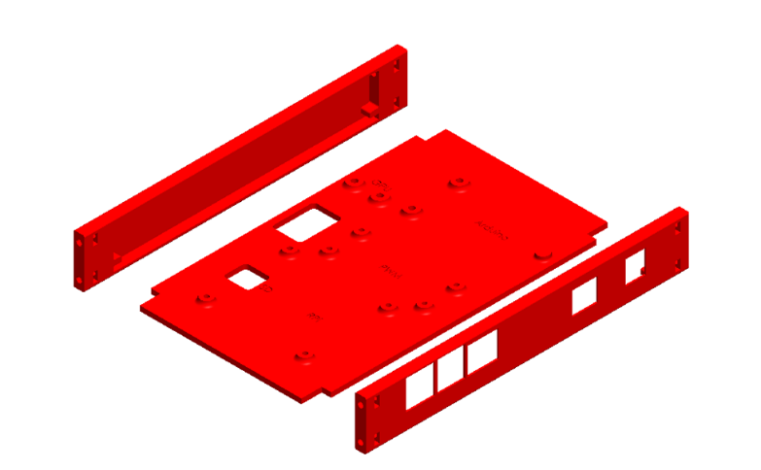Attach the left and right-side plates to corresponding sides of the base plate.

» Step 2:

Attach Arduino to base plate using M3x8 screws with M3 nuts. The base plate has slots cut out directly for the nuts to be held in.

{ADDITIONAL} If using Arduino Mega Plate skip steps 3 and 4, Arduino Uno provides enough room for an Accelerometer on the base plate

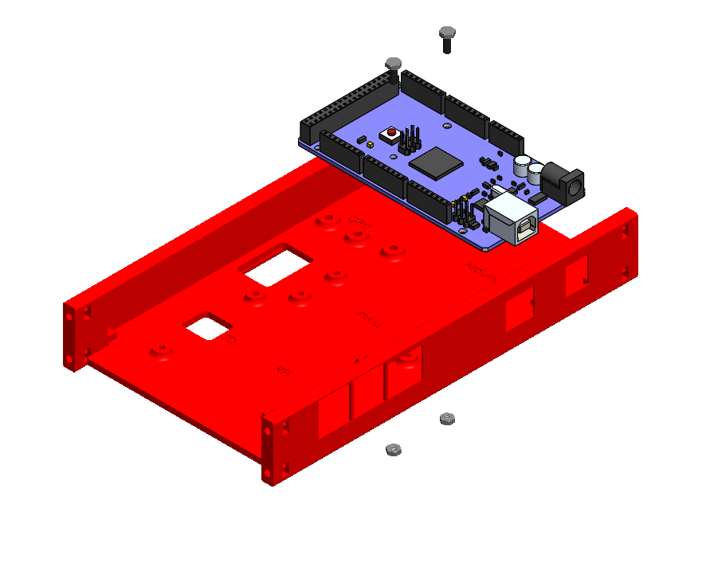

» Step 3:

Solder connecting pins to the Accelerometer (8 breakaway PCB header pins).

» Step 4:

Attach accelerometer to the front of the baseplate using M3x8 screws and M3 Nuts.

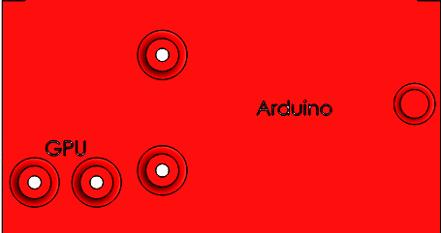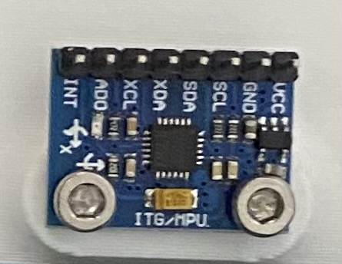

» Step 5:

Solder additional connecting pins to the PCA board and solder the desired I2C location address with the binary linking.

{ADDITIONAL} For ease, skip soldering the binary linking of the I2C address and the I2C address corresponding with the board will be (0x40)

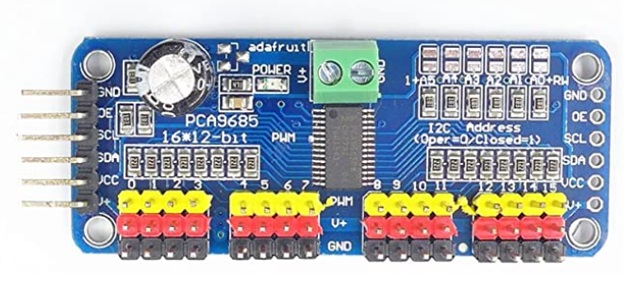

Additional Connecting Pins

I2C address Linking

Middle Power Connection

Connecting Pins

Servo Connecting Pins

»Step 6:

Attach PCA9685 PWM Board to base plate using M2x8 screws and M2 nuts.

{ADDITIONAL} Connect power and ground wires to the middle connectors on the PCA board before screwing in for ease of wire connection. You do not have to connect these wires to batteries yet

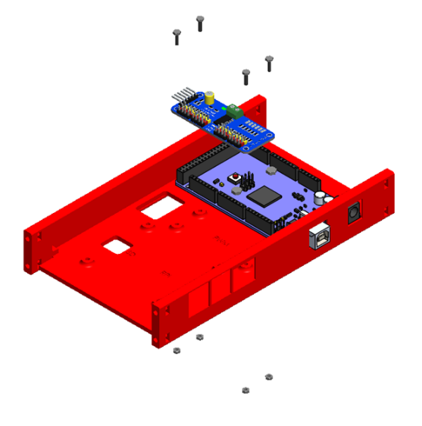

»Step 7:

Attach Raspberry Pi to base plate using M2x8 screws and M2 nuts.

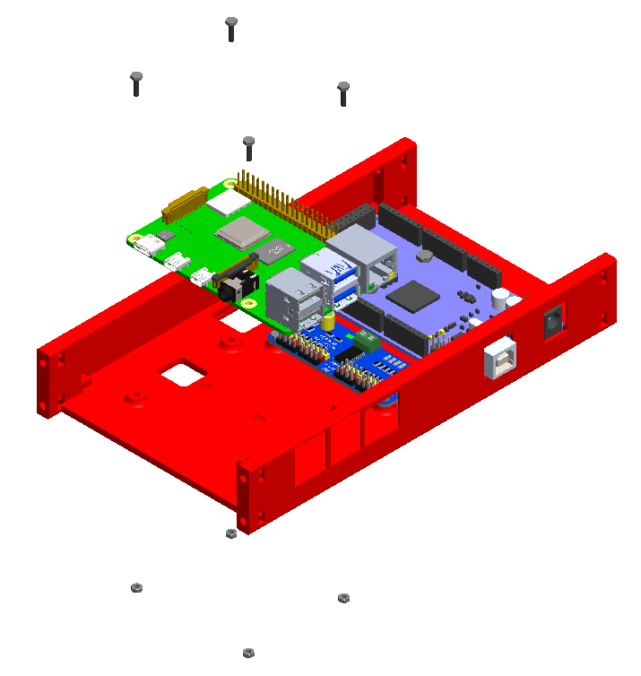

» Step 8:

Attach both inside shoulders to modified left and right-side plates using M3x12 screws with M3 nuts.

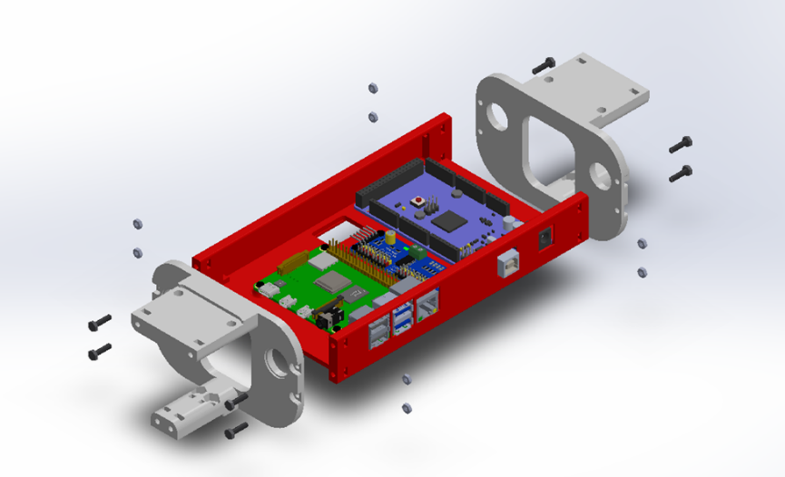

» Step 9:

Snap flanged bearings into holes on both inside shoulders.

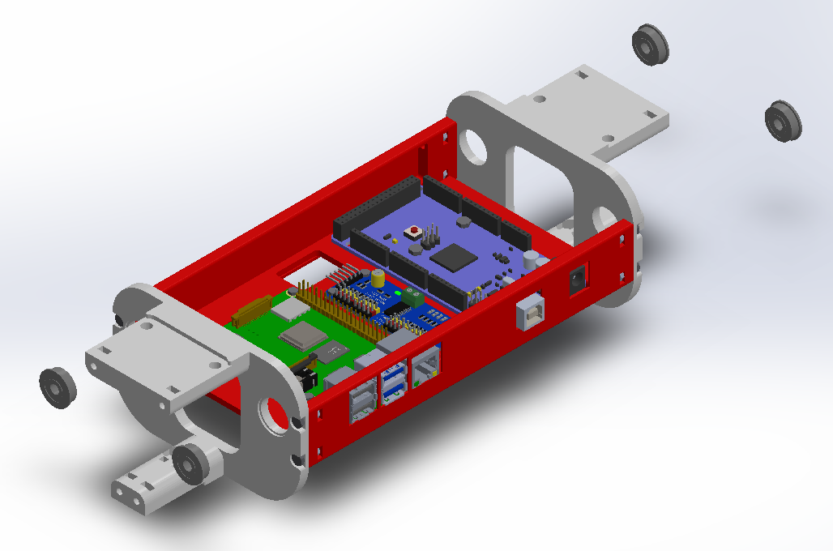

*Part 2: Legs Assembly:*

{These steps follow the picture instructions for Left Leg Assembly, same steps are followed for Right Leg Assembly using ‘Right’ parts instead of ‘Left’}

{Before inserting servos into servo horns, make sure each servo is functioning and calibrate them so their neutral position, 90 degrees, is attached directly vertically or horizontally to the adjacent connection point (not as shown in pictures). Go to ELECTRICAL ASSEMBLY instructions for more details}

» Step 1:

Snap on foot to base of leg.

{Additional} Sand down horizontal edges of raised section of bottom connection point of leg as needed to press fit the feet

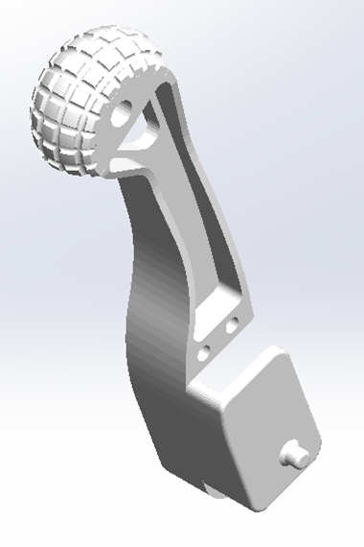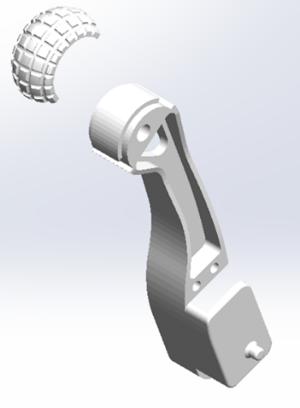

» Step 2:

Insert servo into the servo mount on leg with cable facing away from foot and screw in using M4x20 screws and M4 nuts.

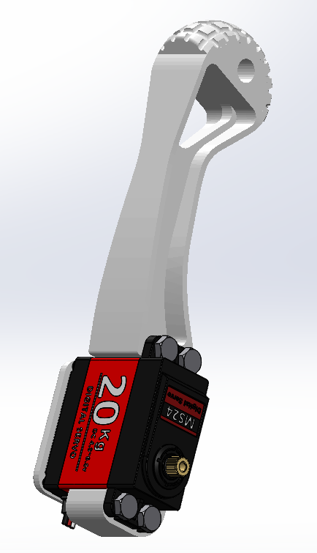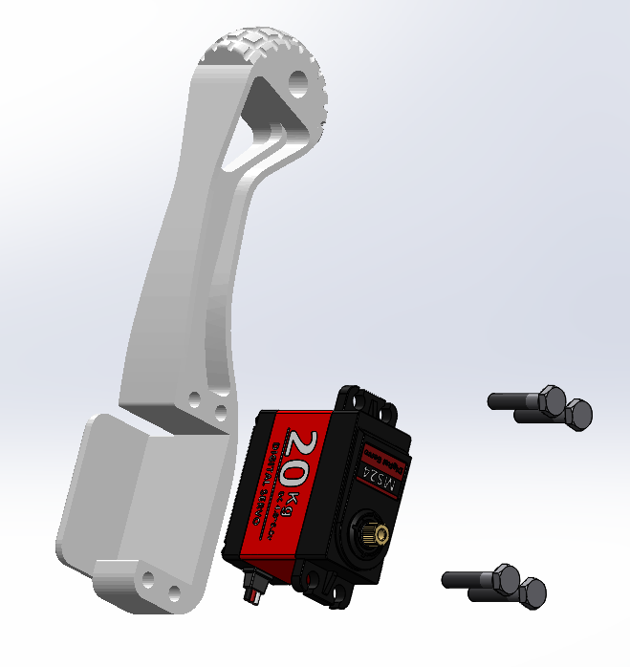

» Step 3:

Insert one-prong servo horn into the slot on the arm using super glue.

{Additional} Cut off one end of the two-prong servo horn if that is what is included in motor pack.

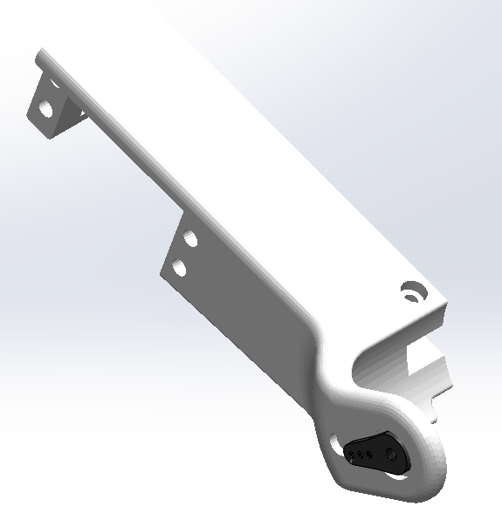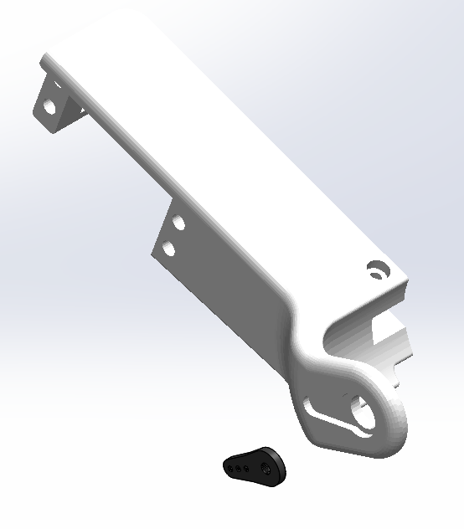

» Step 4:

Press fit flange bearing into bearing slot on the arm cover.

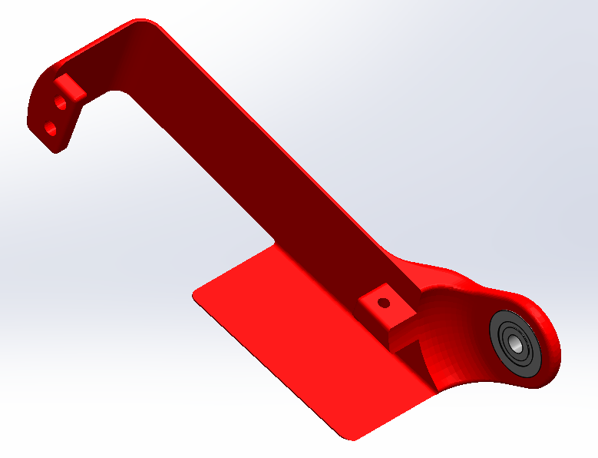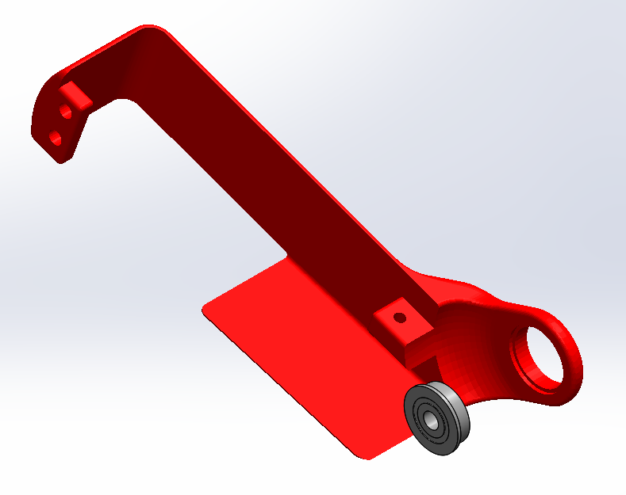

» Step 5:

Attach arm to the leg by pressing the servo gear through the servo horn, and servo screw through servo horn screw into the servo horn.

» Step 6:

Line up the servo wire along the channel on the ar. Attach arm cover by connecting the bearing to the pin on the side of the leg and screw slots on cover to corresponding slots on arm

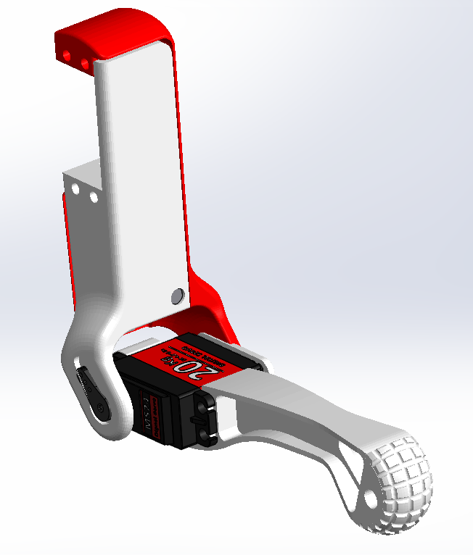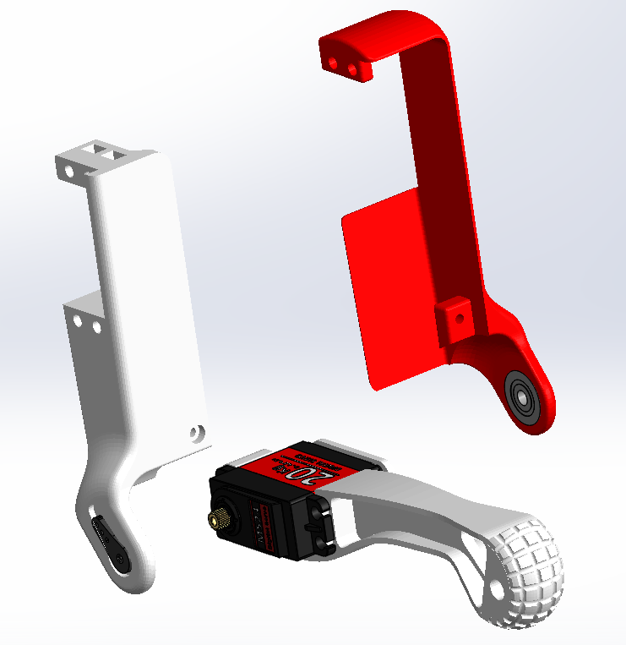

» Step 7:

Screw left arm into the left arm cover using an M3x16 screw and an M3 nut.

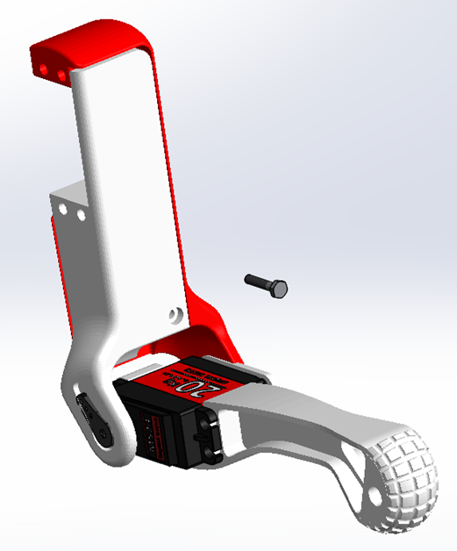

» Step 8:

Insert another servo into the servo mount on the left arm and screw in using M4x20 screws and M4 nuts.

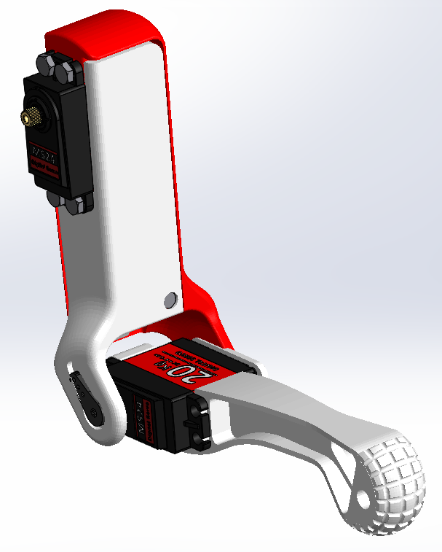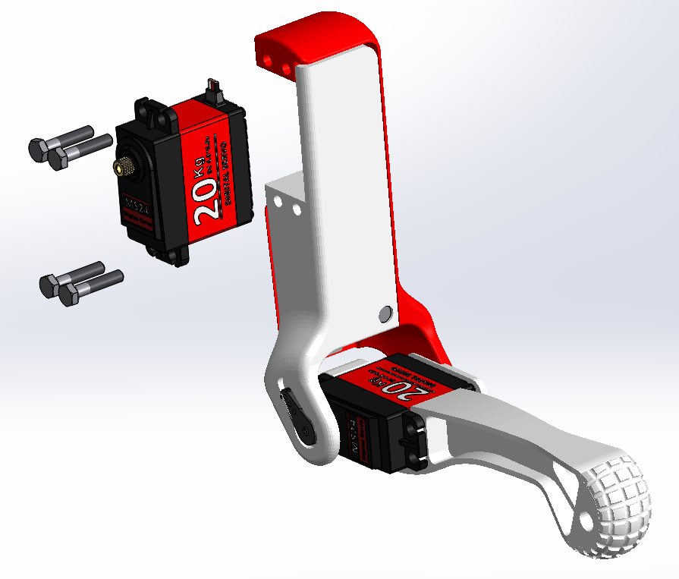

» Step 9:

Repeat steps 1-8 for the second left leg assembly.

» Step 10:

Repeat steps 1-9 for the two right leg assemblies, using right side parts instead of left.



*Part 3: Shoulders Assembly:*

» Step 1:

Attach the 4 prong servo horns into the mount on the inside of each shoulder using super glue.

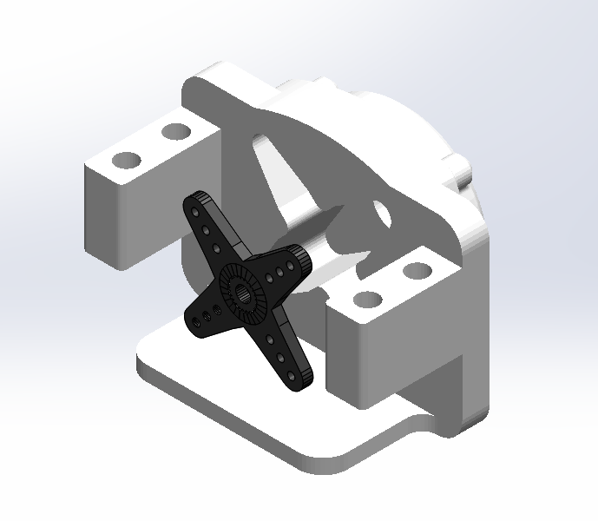

» Step 2:

Insert 2 six prong servo horns into each outside shoulder using super glue.

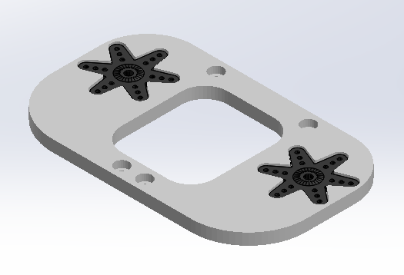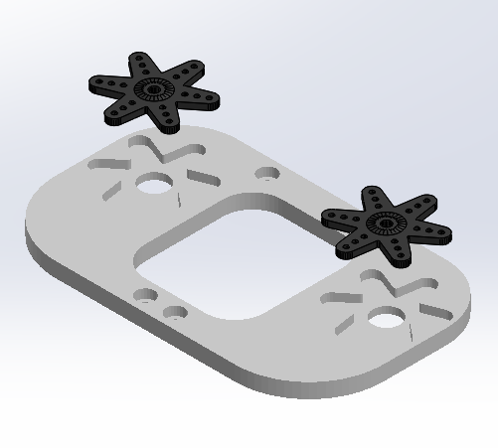

{IMPORTANT} The way you want your feet aligned determines the way you assemble your shoulders. If you want the feet aligned naturally, follow the following steps for front and back legs and shoulders assembly. If you want the feet aligned so they bend towards each other follow the front assembly for both front and back legs.

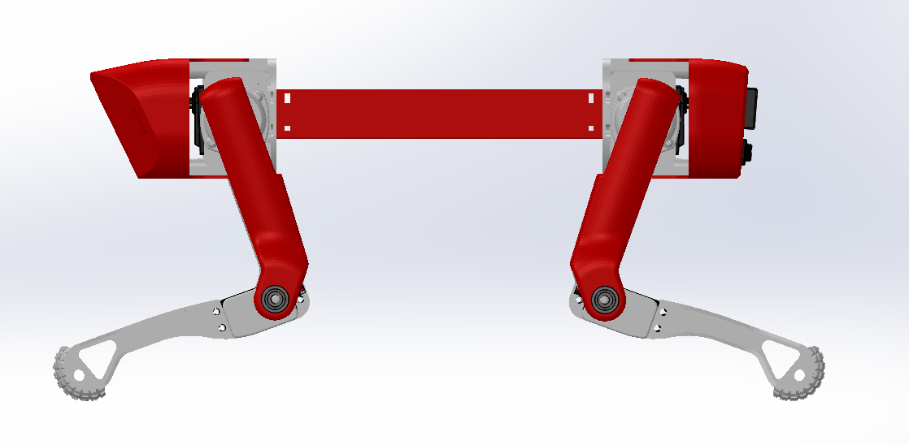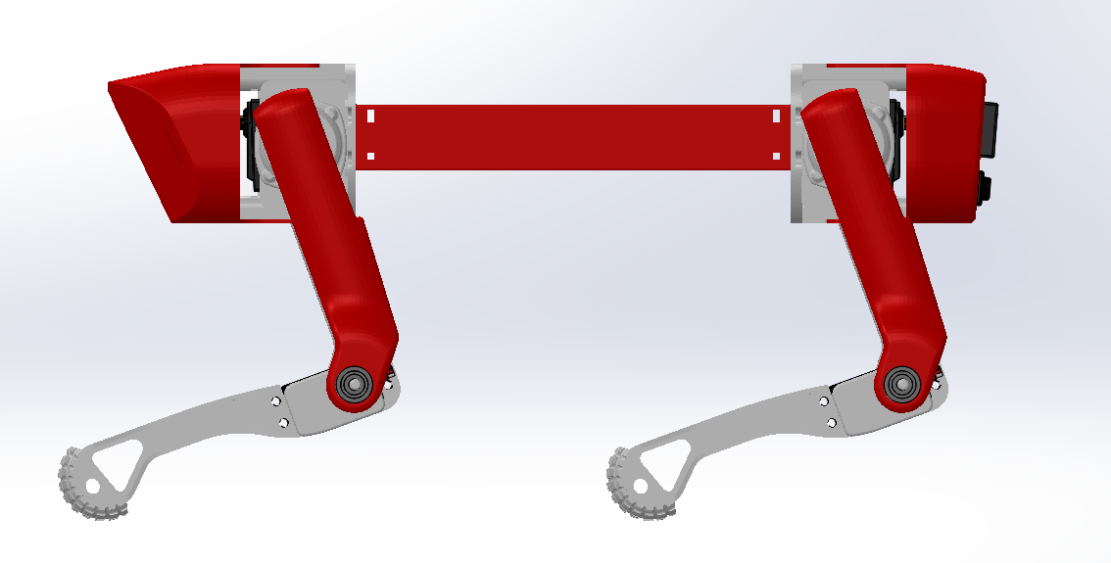

Naturally Aligned Feet

Feet Bent Towards Eachother

-Front Legs and Shoulders-

» Step 2:

Attach the LEFT shoulder to the LEFT arm assembly by pressing the servo pin through the four-prong servo horn, and screw servo screw through the four-prong servo horn into the servo gear.

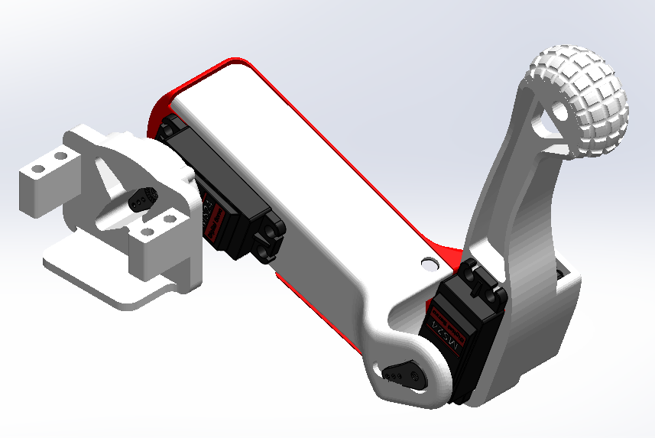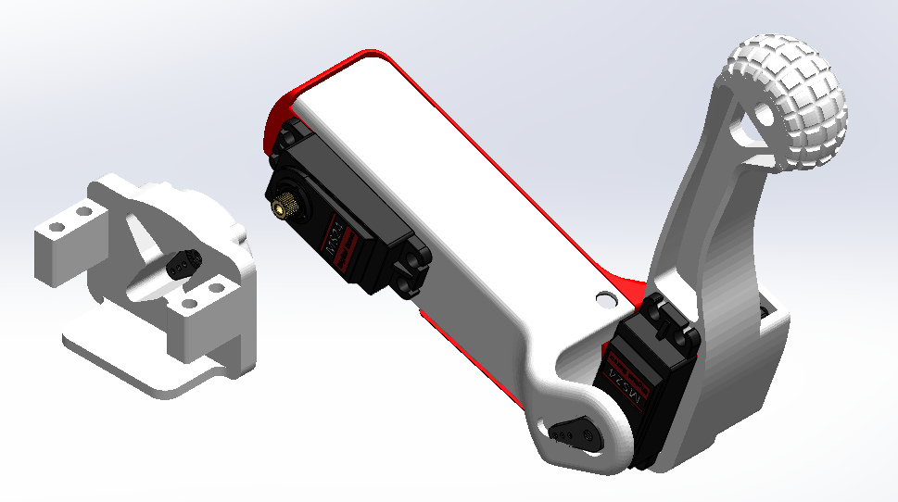

» Step 3:

Insert another servo into the servo mount on the left shoulder and screw in using M4x20 screws and M4 nuts.

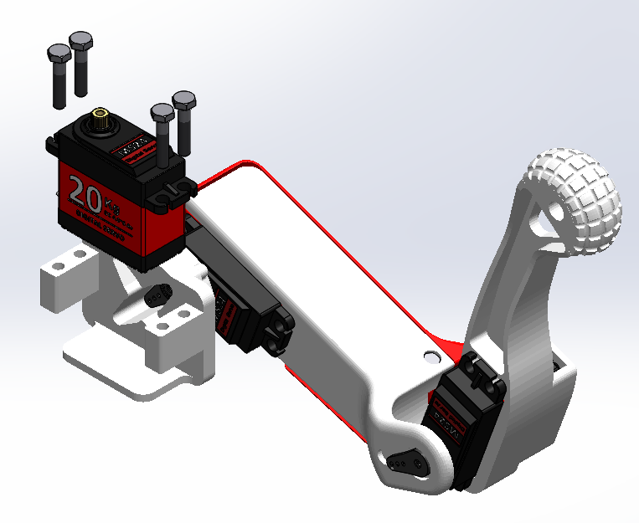

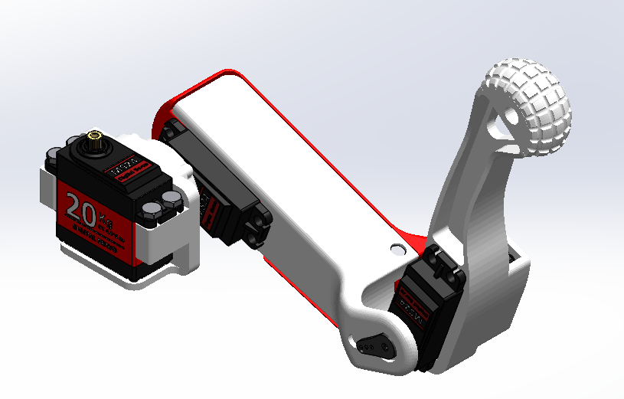

» Step 4:

Attach the RIGHT shoulder to the RIGHT arm assembly by pressing the servo pin through the four-prong servo horn, and screw servo screw through the four-prong servo horn into the servo gear.



» Step 5:

Insert another servo into the servo mount on the right shoulder and screw in using M4x20 screws and M4 nuts.





» Step 6:

Attach left front shoulder assembly and right front shoulder assembly to the outside shoulder by pressing the servo pins through the six prong servo horns and screw in the servo horn screws. 6-prong servo horns facing forward.

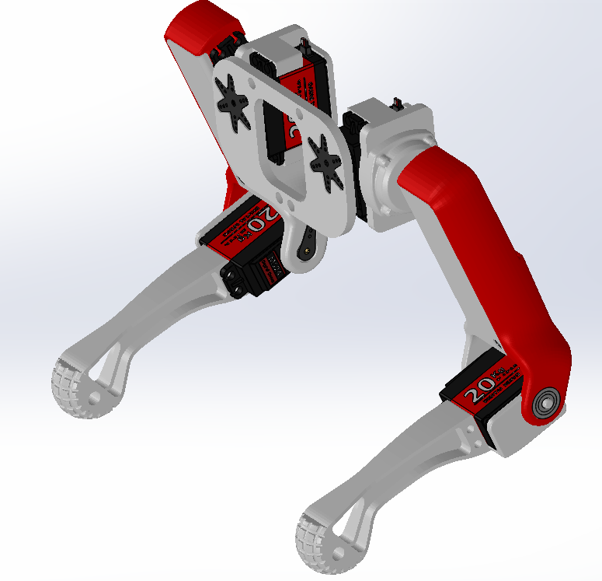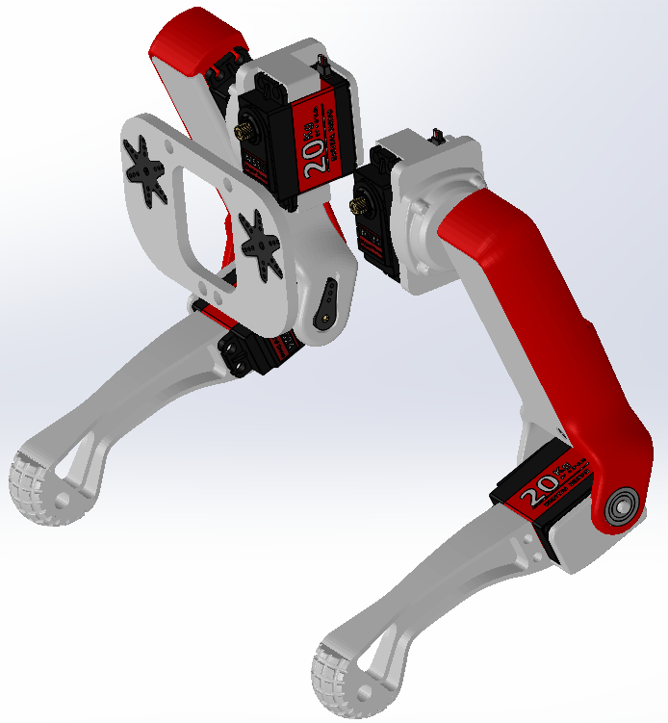

-Back Legs and Shoulders-

» Step 7:

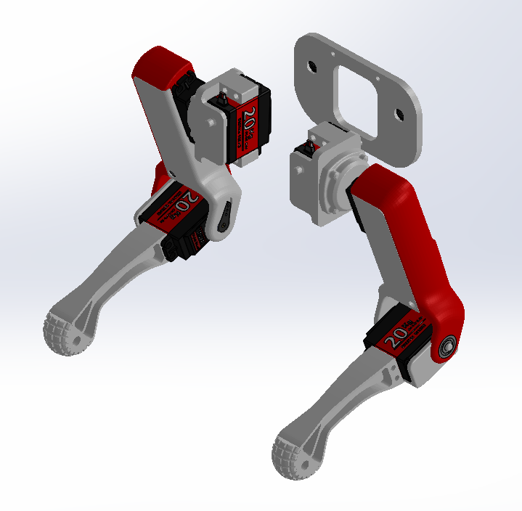Attach the RIGHT shoulder to the LEFT arm assembly by pressing the servo pin through the four-prong servo horn, and screw servo screw through the four-prong servo horn into the servo gear.

» Step 8:

Insert another servo into the servo mount on the right shoulder and screw in using M4x20 screws and M4 nuts.

» Step 9:

Attach the LEFT shoulder to the RIGHT arm assembly by pressing the servo pin through the four-prong servo horn, and screw servo screw through the four-prong servo horn into the servo gear.

» Step 10:

Insert another servo into the servo mount on the right shoulder and screw in using M4x20 screws and M4 nuts.

» Step 11:

Attach left back shoulder assembly and right back shoulder assembly to the other outside shoulder by pressing the servo pins through the six prong servo horns and screw in the servo horn screws. 6-prong servo horns facing back.

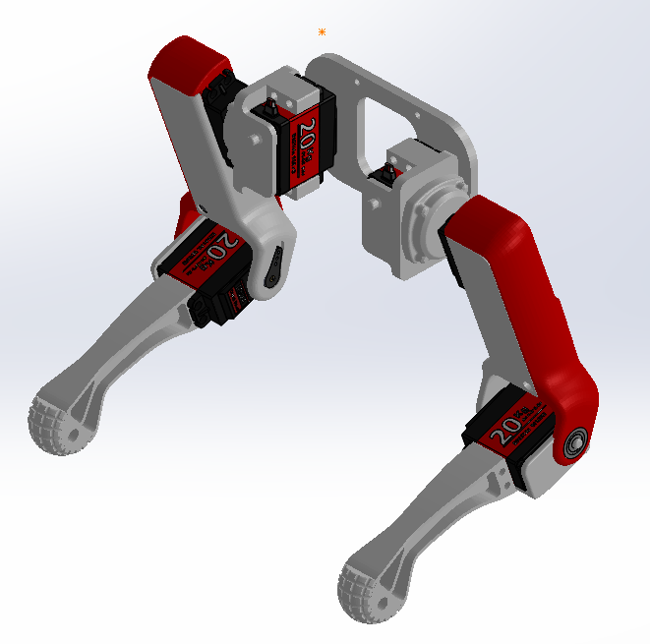

*Part 4: Covers Assembly:*

» Step 1:

Press fit both ultrasonic sensors into both left and right ultrasonic plate

{ADDITIONAL} Attach lead wires to pins on the Ultrasonic Sensors

» Step 2:

Super glue left and right ultrasonic plate assemblies into their respective slots on the front face cover.

{ADDITIONAL} Screw in RPi camera into RPi camera mount and press fit plate into front face cover.

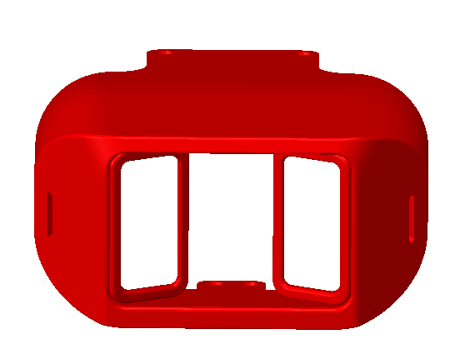

Left US Mount

Right US Mount

RPi Camera mount Mount

» Step 3:

Press fit and Hot Glue 16x2 LCD screen into corresponding slot in back rear cover.

{ADDITIONAL} Attach lead wires to pins on the LCD Screen

» Step 4:

Press fit Rocker Switch into corresponding slot in back rear cover. For now, wires will be loose.



LCD Screen Slot

Rocker Switch Slot

*Part 5: Final Assembly:*

» Step 1:

Attach Front and Back Shoulder assembly to main body assembly by inserting pins on the left and right shoulders to the corresponding bearing in on both front and rear Inside Shoulder.

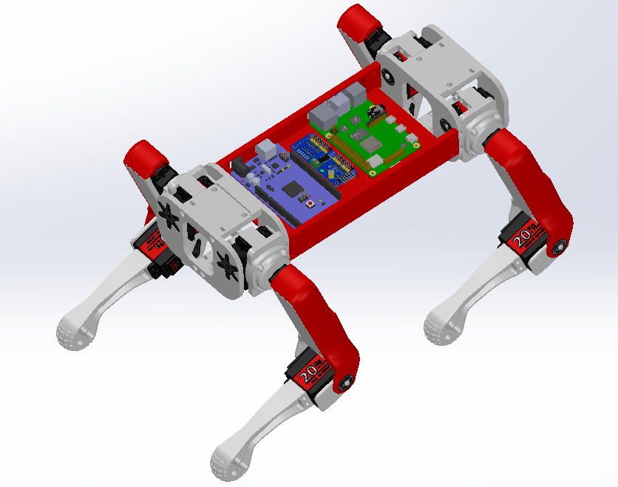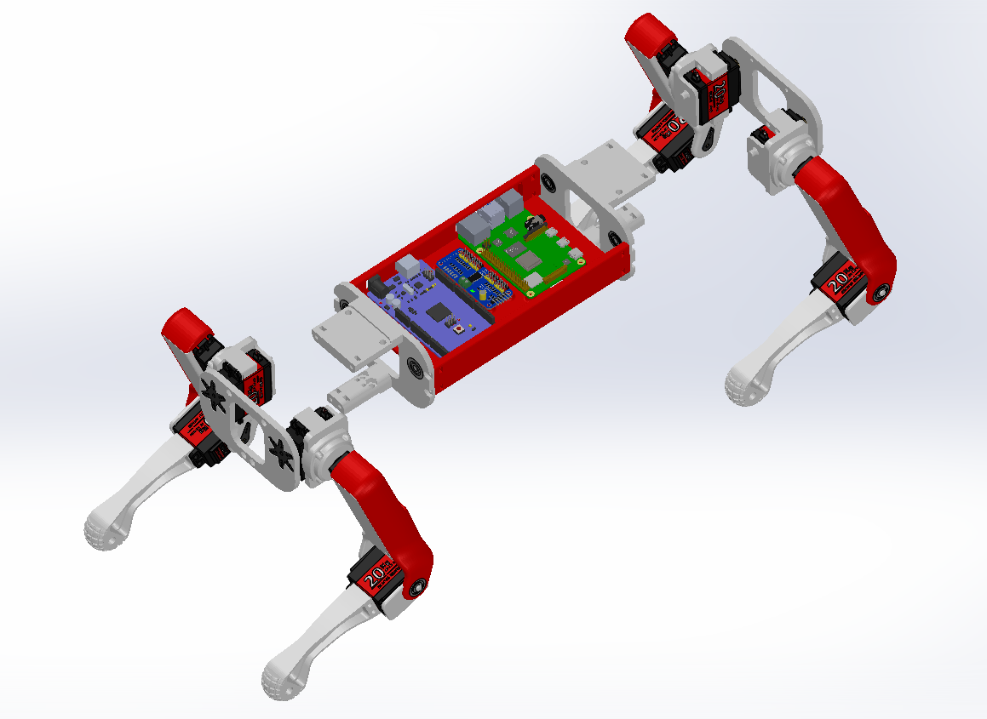

» Step 2:

Screw front outside shoulder to front inside shoulder using M3x20 screws with M3 nuts.

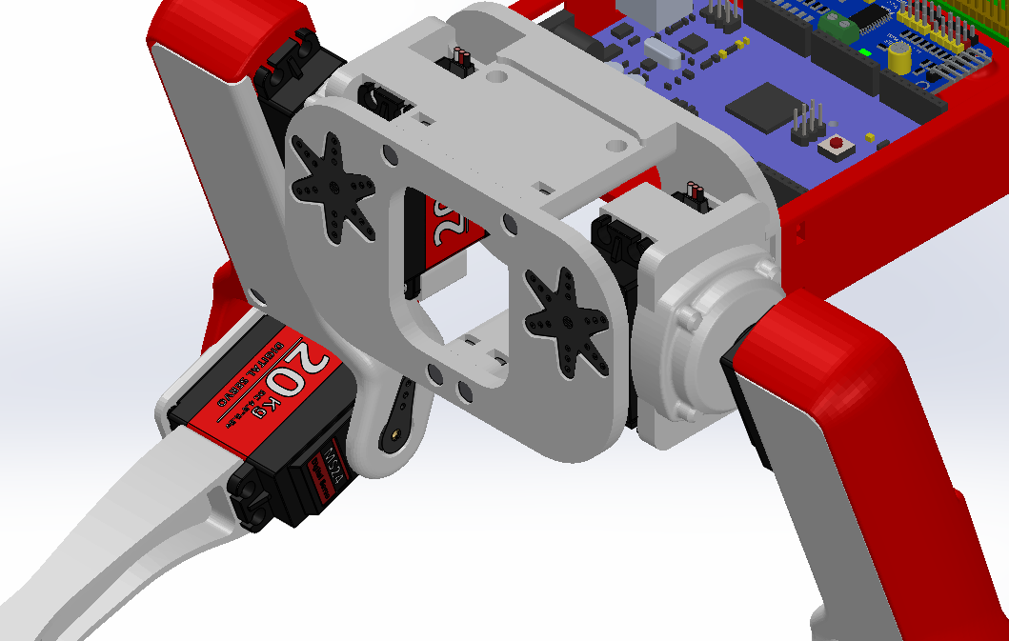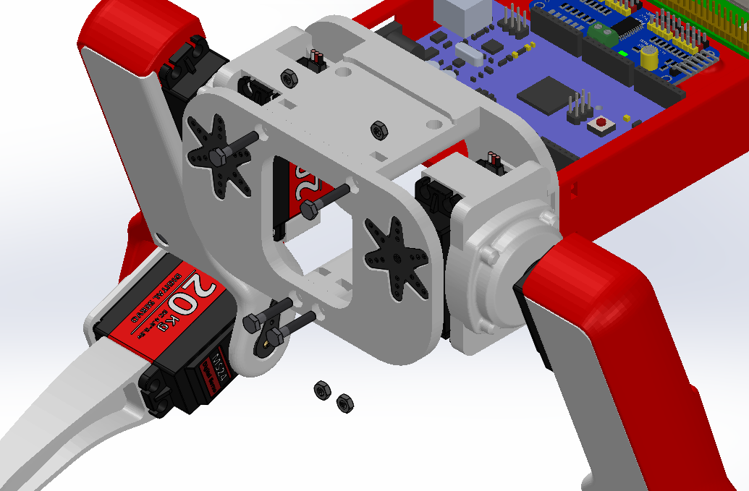

» Step 3:

Screw rear outside shoulder to rear inside shoulder using M3x20 screws with M3 nuts.

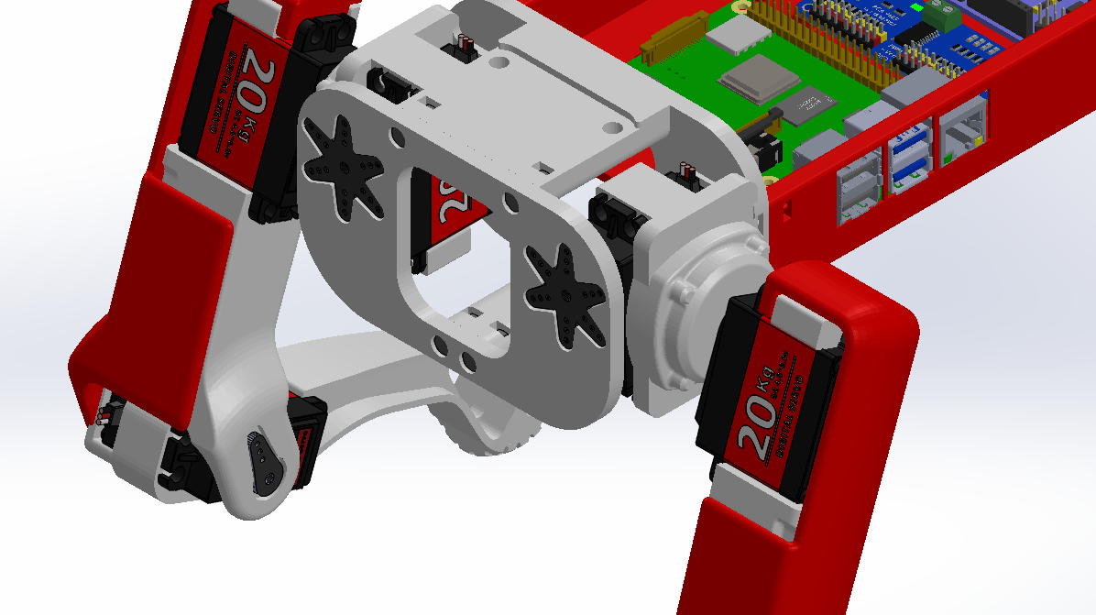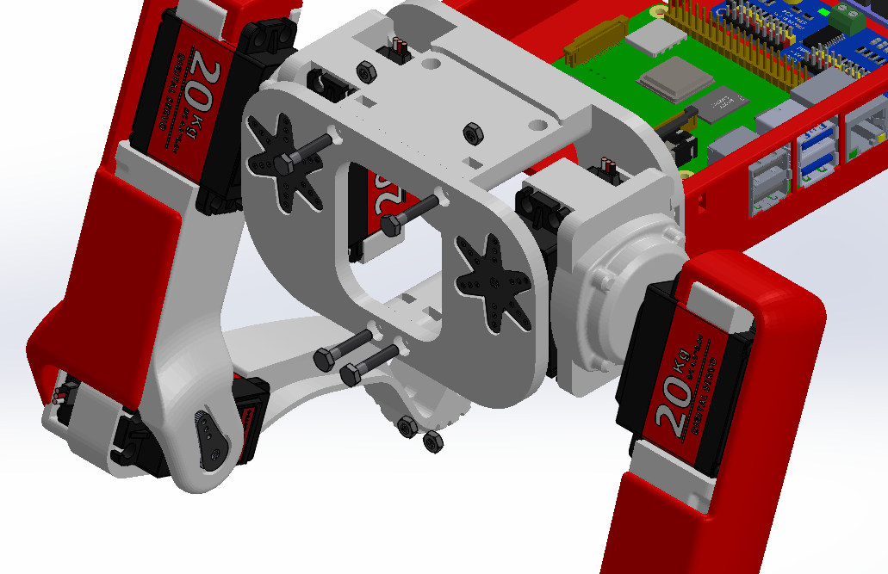

» Step 4:

Press fit front cover onto front outside shoulder.

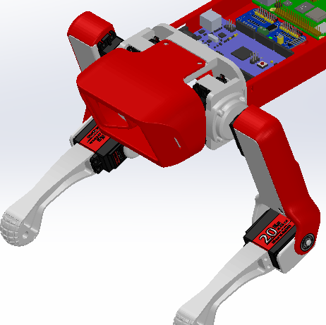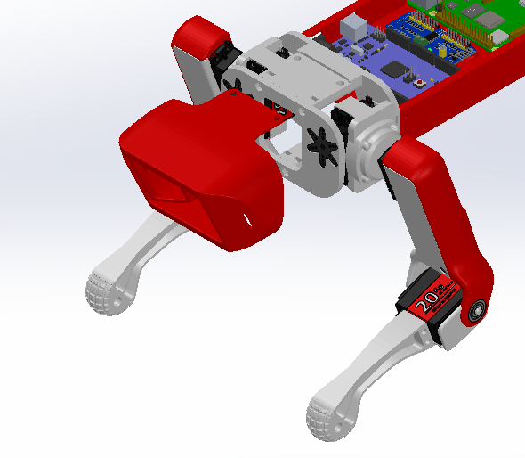

» Step 5:

Press fit rear cover onto rear outside shoulder.

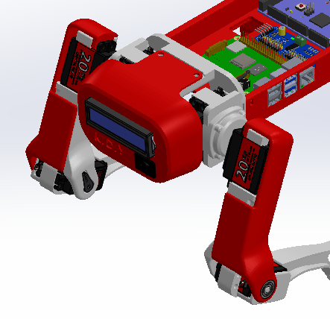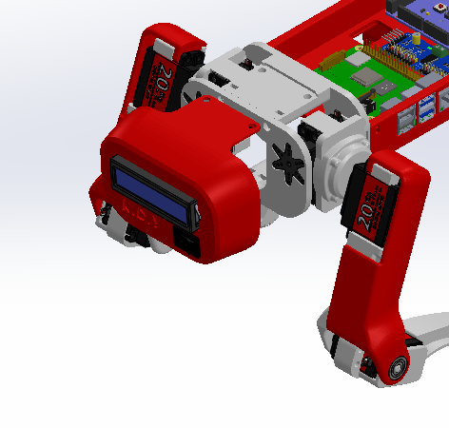

» Step 6:

Place top cover on top of the body, lining up screw holes on with front and rear covers and inside shoulders. Screw in M4 screws and M4 nuts into corresponding screw holes.

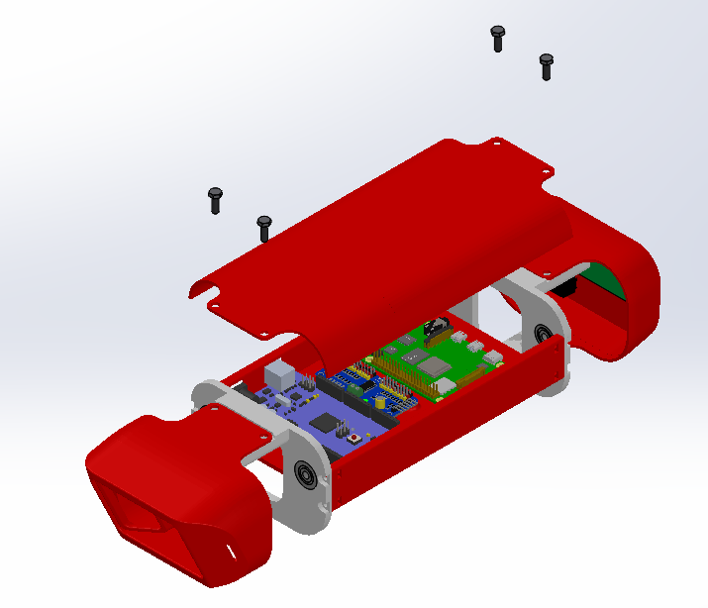

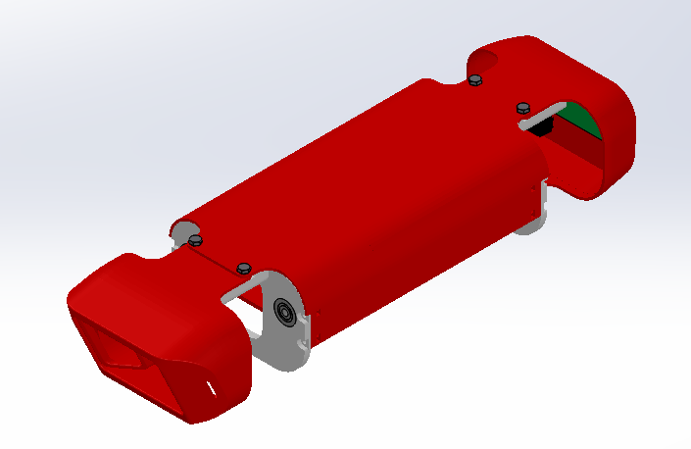

» Step 7:

Flip over robot. Place bottom cover on bottom of the body, lining up screw holes on with front and rear covers and inside shoulders. Screw in M4 screws and M4 nuts into corresponding screw holes.

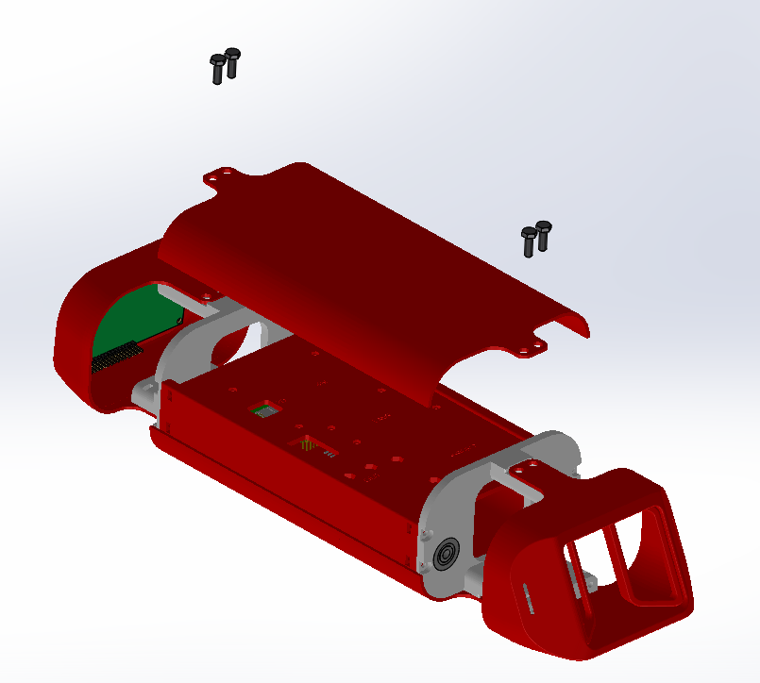

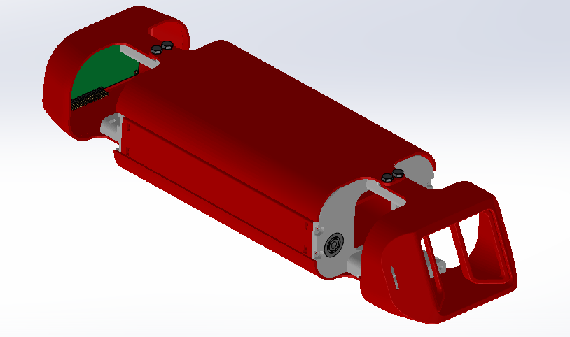

Congratulations, following these steps you should now have your own Mini-HART assembled and ready for wiring!

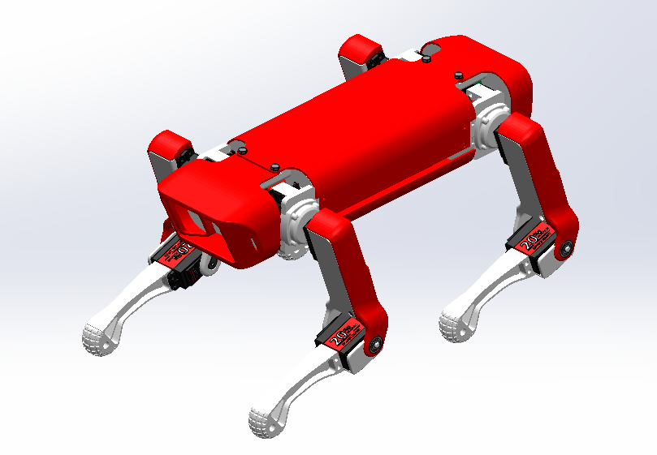

Electrical Assembly:

*Pin Diagrams:*

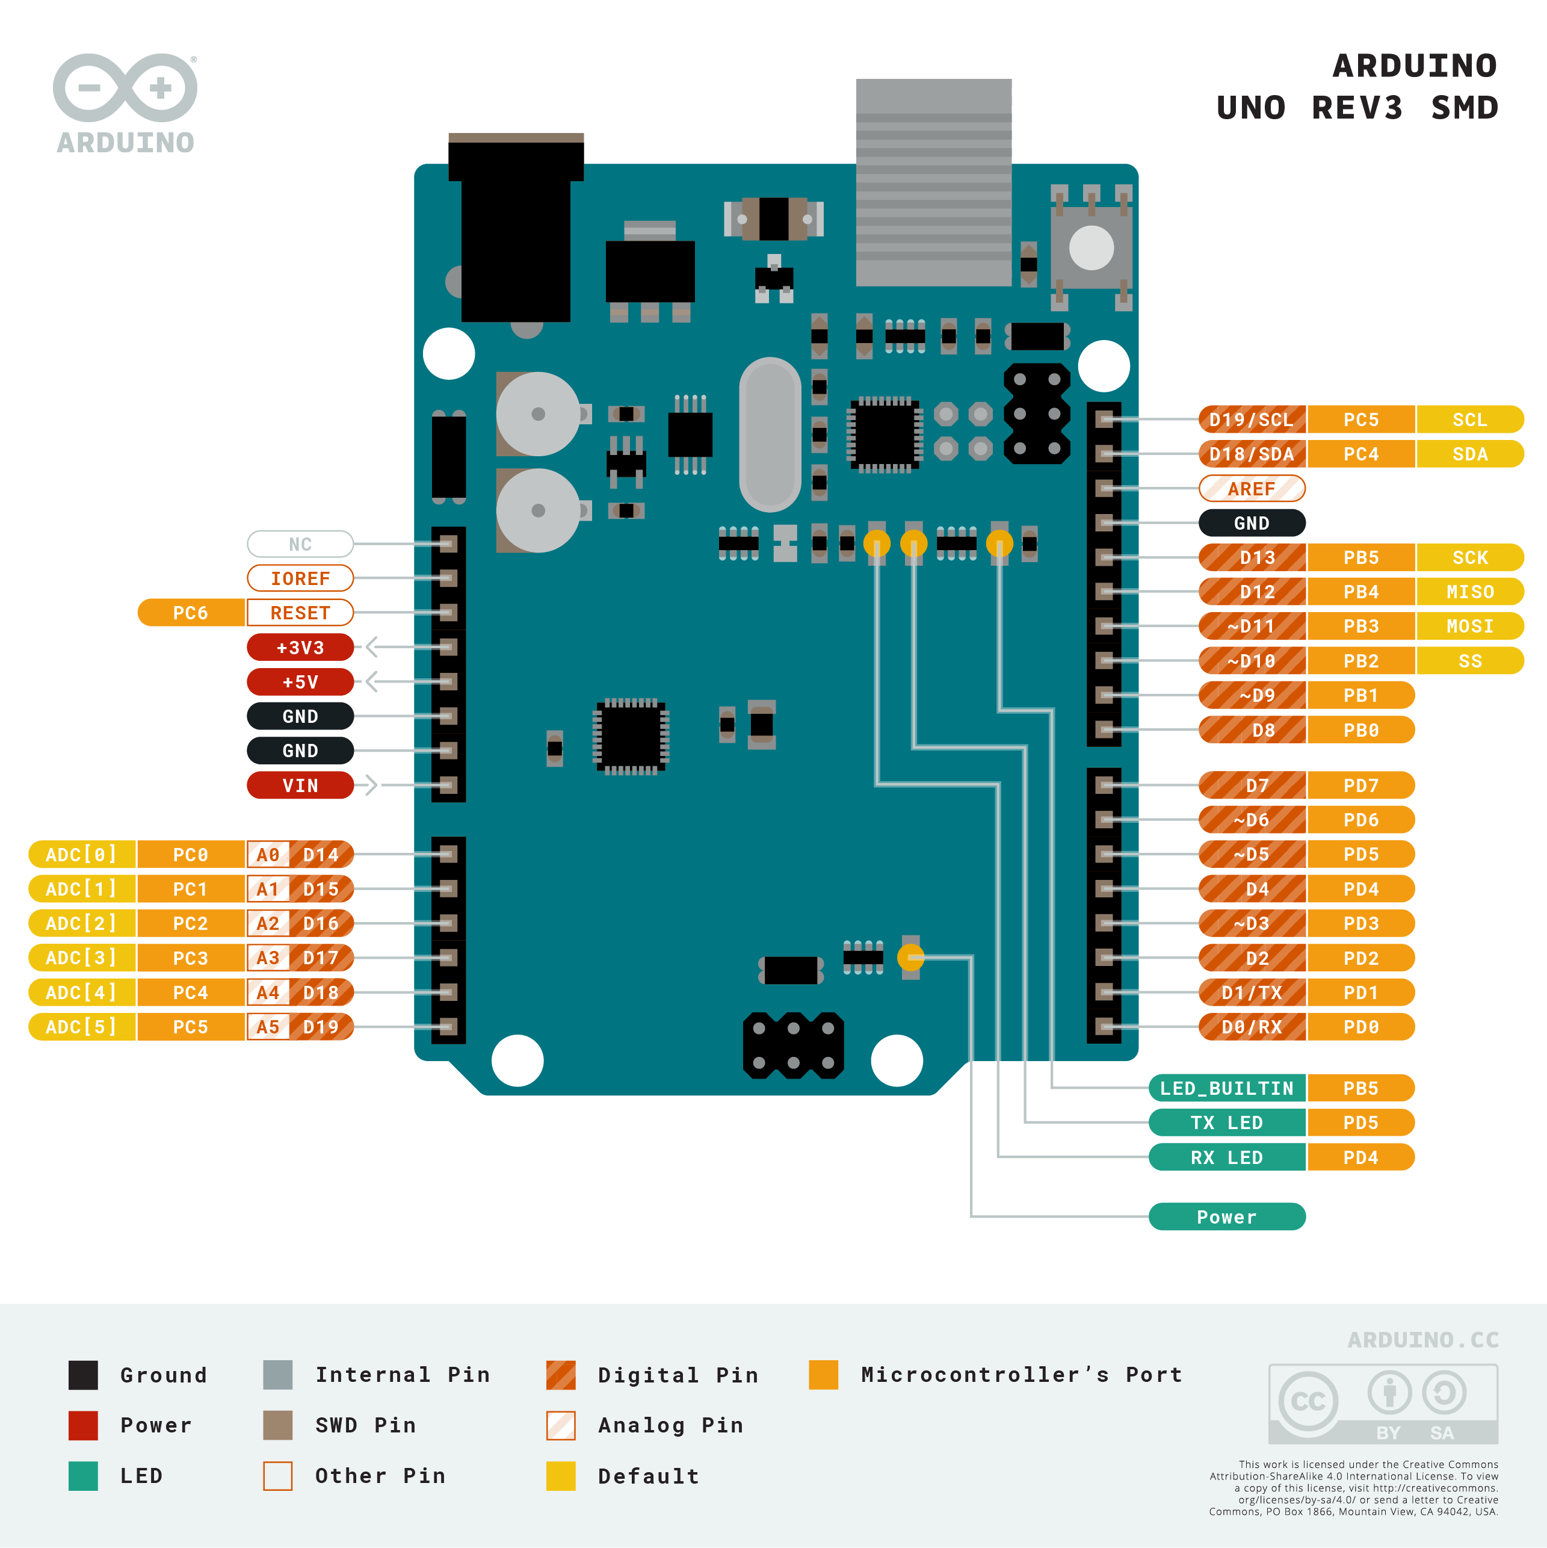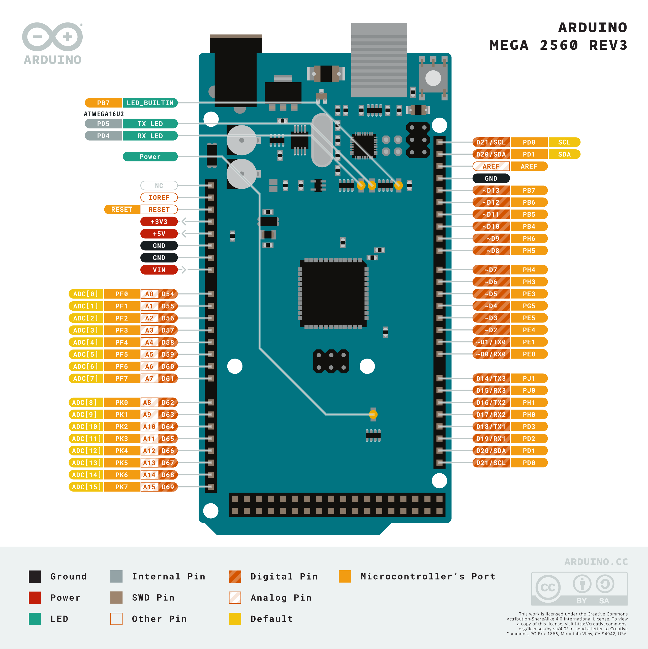With all the other electrical parts obtained in the bill of materials, you can now start wiring up your Mini-HART. This section is a guide of how to connect your lead wires to and from the various electrical components. Below are the pin diagrams for Arduinos (Uno and Mega) as well as a Raspberry Pi 4B and PCA9658 PWM Board.

Arduino Uno [ ]

Arduino Mega [ ]

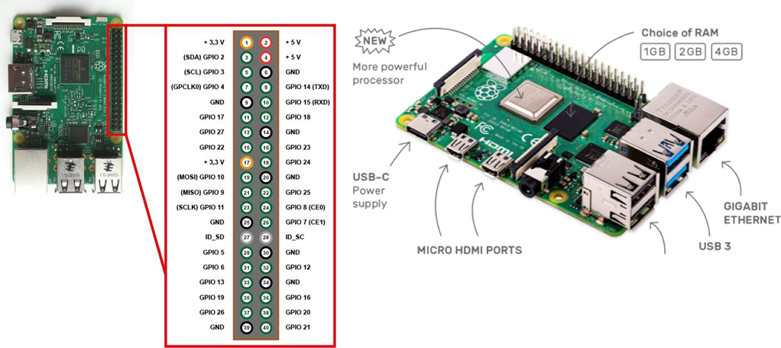

Raspberry Pi 4B [ ]

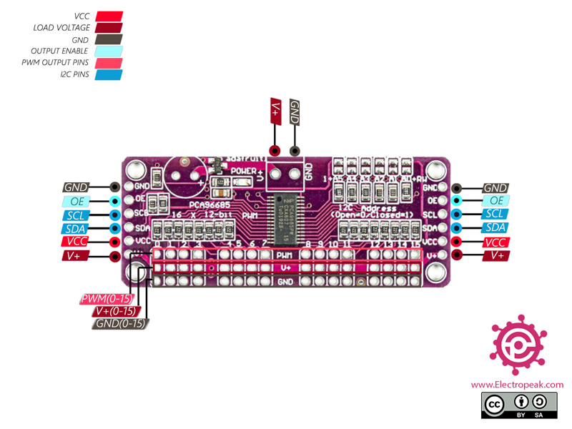

PCA9685 [ ]

*Servo Calibration:*

{Before attaching servos in the mechanical assembly, follow these guides to calibrate your servos, which makes coding easier}

To calibrate your servos into their neutral positions, you can follow 2 different approaches. The first approach utilizes a servo tester (Servo Consistency Master) to get the neutral position. The second approach has you wiring up your servos to the PCA9685 and connecting the PCA9685 to the Arduino, then following an Arduino code (following the next steps *Motor Wiring*).

First Approach:

Using a servo tester, as seen in picture, connect power and ground to the input of the tester and connect the servo you are calibrating to one of the servo rows on the other side. Press the select button until the Neutral Light on the tester is lit up. Your servo is now in the neutral position and ready to be assembled in the following way.

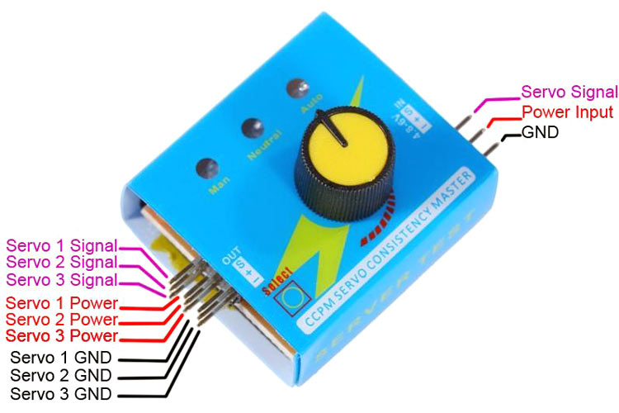

Neutral Point LED

Mode Selector

Second Approach:

This approach is a more accurate way of calibrating your servos but requires more set up and flipping through this manual. Following the steps that follow in the *Motor Wiring* instructions, connect your servos to their respective pin column numbers. Next attach the connection pins on the side of the PCA9685 board to the Arduino as seen in following the *Wiring Connection* instructions. Lastly, run the Arduino code ‘Test_Neutral” from the *Arduino Coding* instructions. With all of this set up, run the code and all the servos should go into their neutral 90-degree positions.

With the servos now calibrated to be in their neutral position, you can attach the servos to the servo horns on their respective limbs. Follow this image as to how to attach each of the servos when in their neutral position (0 deg):

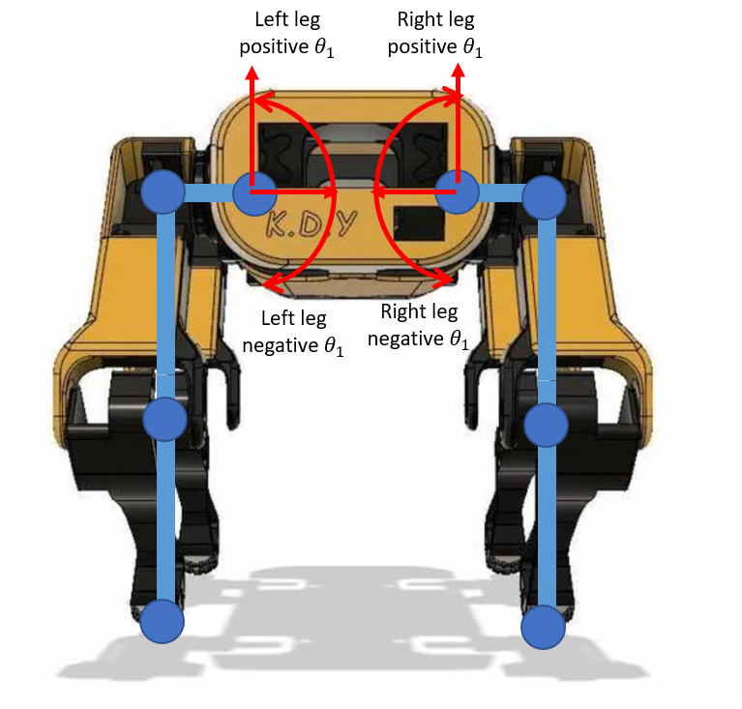

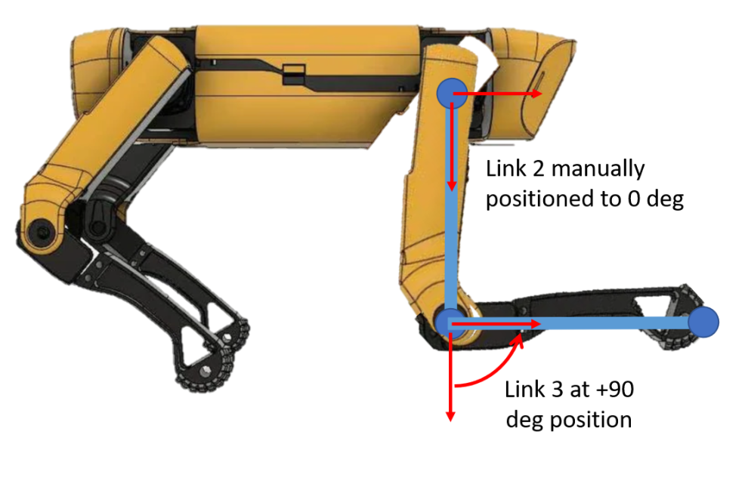

As you can see, the servos on the leg are connected at 90 degrees with the arms, the arms vertically aligned with ground and connected to the shoulders, and the servos connecting the shoulder with the body are squared and horizontal with the ground. This configuration would be the best when programming the robot.

*Motor Wiring*:

With the PCA9685 PWM Board, the motor connection is very simple. Connect the yellow-red-black wire of the servo motors to the respective yellow-red-black pin column on the PCA9685. These columns are numbered 0 through 15 and are very important to denote which servos destination you connect them to. The order the Mini-HART is wired is as follows. Nonetheless, you can wire up the servos however you please, but make sure you denote where the connections are leading to and change the codes accordingly.

|  |  |
| --- | --- |
| PCA 9685 | |
| Servo Location | Pins # |
| Front Right Leg | 0 |
| Front Right Arm | 1 |
| Front Right Shoulder | 2 |
| Back Right Leg | 3 |
| Back Right Arm | 4 |
| Back Right Shoulder | 5 |
| Back Left Leg | 6 |
| Back Left Arm | 7 |
| Back Left Shoulder | 8 |
| Front Left Leg | 9 |
| Front Left Arm | 10 |
| Front Left Shoulder | 11 |

*Wire Connections:*

Wiring the components to each other is fairly trivial. Follow the schematic and pin connection tables for where to connect each component to the Arduino and/or the Raspberry Pi. These are the base components; additional components can be added or existing ones like the LCD Screen and Accelerometer could be removed. The Arduino Mega provides a greater amount of connection points, but the Arduino Uno allows for space for the Accelerometer. When hooking up the power and ground of the components in series, solder the connecting wires to a PCB or small breadboard and attach the power and ground on the PCB to the respective components on the Arduino or RPi. Similarly, this can be done if desired to connect the SDA’s and SCL’s in series on a PCB. Lastly, it is common practice to not have the PCA9865 connected to both the Arduino and RPi at the same time, using connecting wires it is simple to disconnect one while the other is in use.

|  |  |  |
| --- | --- | --- |
| Arduino | |  |
| Connection | Pin # | Color |
| PCA SCL | PWM - SCL 1 | Blue |
| PCA SDA | PWM - SDA 1 | Yellow |
| PCA Power | Power - 5V | Red |
| PCA Ground | PWM -Ground | Black |
| PCB Power | Power - 3.3 V | Red |
| PCB Ground | Power - Ground | Black |
| Ultrasonic Left Echo | D - 47 | Green |
| Ultrasonic Left Trig | D - 49 | Orange |
| Ultrasonic Right Echo | D - 51 | Green |
| Ultrasonic Right Trig | D - 53 | Orange |
| Accelerometer SCL | A - 15 | Blue |
| Accelerometer SDA | A - 14 | Yellow |
| LCD SCL | A - 6 | Blue |
| LCD SDA | A - 7 | Yellow |

|  |  |  |
| --- | --- | --- |
| Raspberry Pi | |  |
| Connection | Pin # | Color |
| PCA SCL | GPIO 2 - Pin 3 | Blue |
| PCA SDA | GPIO 3 - Pin 5 | Yellow |
| PCA Power | 5V - Pin 2 | Red |
| PCA Ground | Ground - Pin 6 | Black |
| PCB Power | 3.3V - Pin 1 | Red |
| PCB Ground | Ground - Pin 9 | Black |
| LCD SCL | GPIO 2 -Pin 3 | Blue |
| LCD SDA | GPIO 3 -Pin 5 | Yellow |

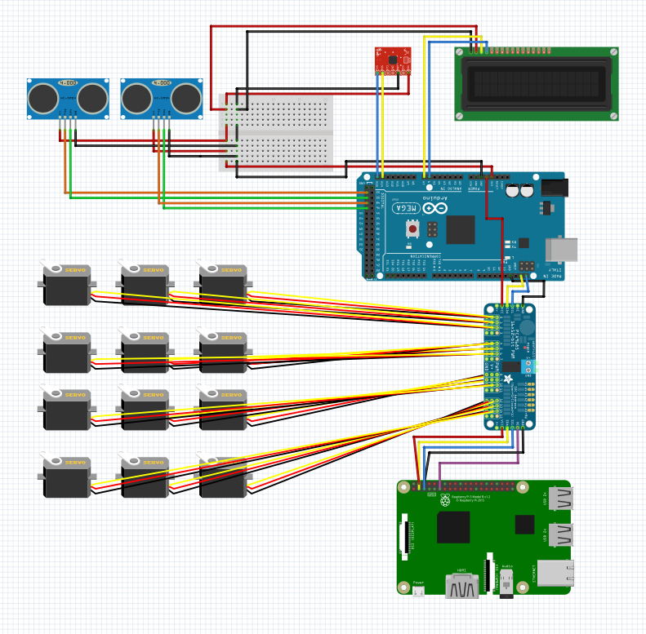

*Battery Connection:*

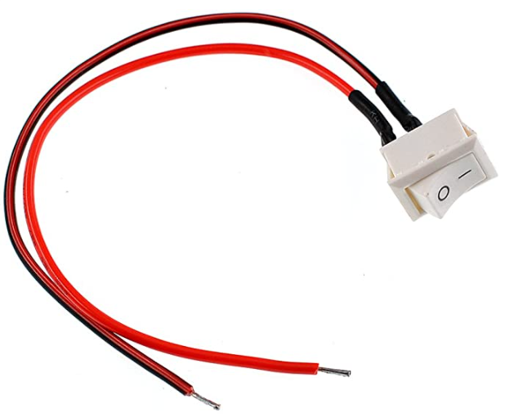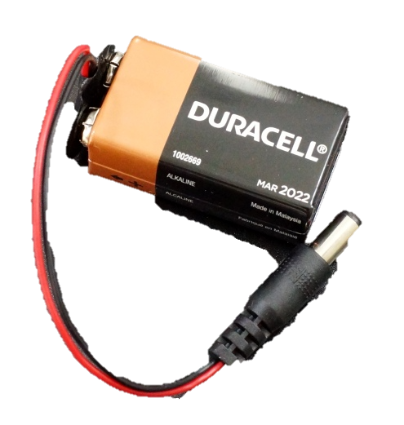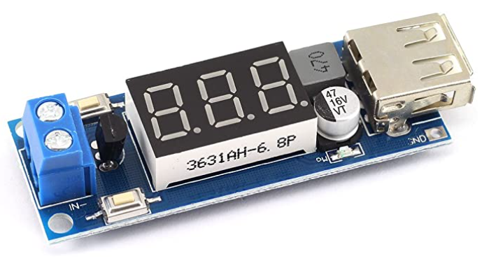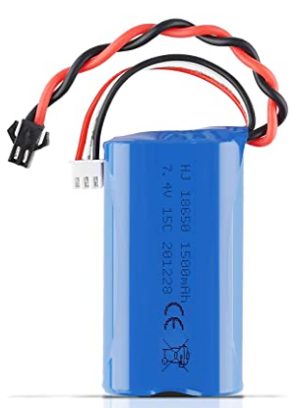The choice of battery is up to you, in the case of the Mini-HART, 2 x 7.4-volt batteries are used. Because the PCA9685 and RPi take an input of 5V, a step-down buck converter is needed to lover the voltage of the batteries down to 5 Volts. In the case of the Arduino, the max input is 12 volts, so a separate 9-volt battery with a DC output connection is used and plugged into the DC input on the Arduino. The buck converters used have a USB A as well as a solderable Power and Ground Wire output. The input on these converters is a blue terminal block where you connect the power and ground of the battery and screw the connection tight. For the 7.4-volt LiPo batteries, use male-male connecting wires to connect to the battery’s connection port and the blue terminal on the buck converter. For the PCA board solder the male-male connecting wire to the output of the buck converter and the blue terminal input on the PCA board. For the Raspberry Pi, connect a USB A to USB C cable to the buck-converter and input the USB C cable into the RPi. Additionally, connect the rocker switch up between the connection of the battery to the step-down converter of the PCA board to cut power to the motors if needed.